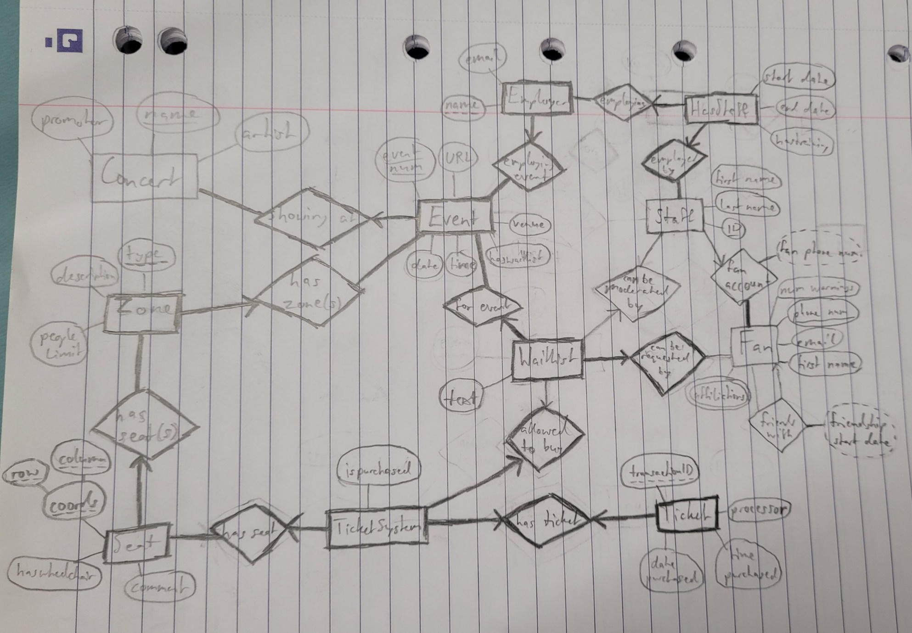

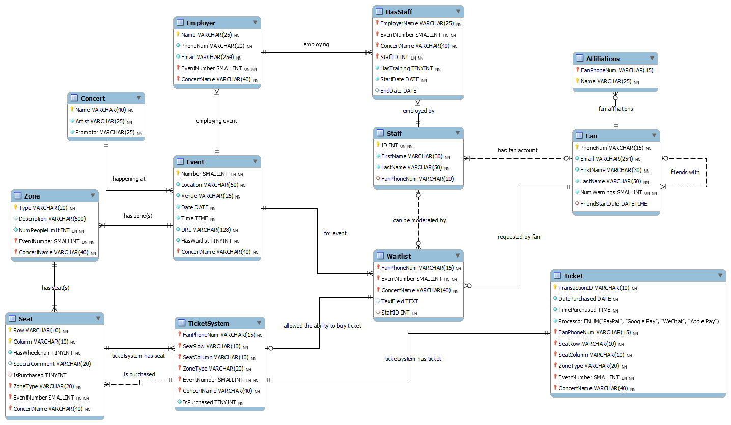

# Assumptions

* URL char size 128 (max size)
* Email char size 254 (max size)
* Phone number char size 15 (max size)
* First name char size 30, last name char size 50 (allow adequate space)
* Location name char size 50 (larger size allowed for composite names e.g. “Melbourne, Australia”)
* Zone type char size 20 (allow space for e.g. “general admission”, but not needed to be any longer as the description should do any needed further explaining)
* Seat/column char size 10 (allow space for e.g. “STANDING”, but have comment attribute for further explanation)
* Seat comment char size 20 (allow another additional zone type char size to distinguish the type within the type)
* All business names (promotor, artist, etc) char size 25
* Concert name char size 40 (large size to accommodate multiple large names e.g. “From Saturday Night Live it’s Jimmy Fallon”)
* Event, warnings num size SMALLINT (obvious small integers but don’t want to use TINYINT for fear of mistaking for Boolean)
* All INTs (except TINYINT) unsigned to discourage integer overload, enable larger sizes while using same space
* Allowing for multiple different employers per event
* Waitlist entry assignment to a ticket allows the ticket to use the concert and event specified in the ticket